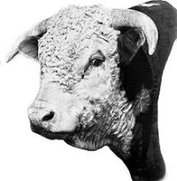
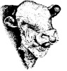
South Western Hereford Association
March 2022
ALL EVENTS OPEN TO ALL HEREFORD BREEDERS & FRIENDS
MESSAGE FROM THE VICE CHAIRMAN
Dear All
Some of you will know me, others not! I want to take this opportunity to make myself know to all. We’ve had a rough few years with Covid affecting everything that we all too often have taken for granted. Our association like many others has suffered over this period. Thankfully the hard work of our secretary Angela has held the ship together for us! The mission now is to take the South Western Hereford Association forward and for us to be seen for what we have to offer here in the South West.
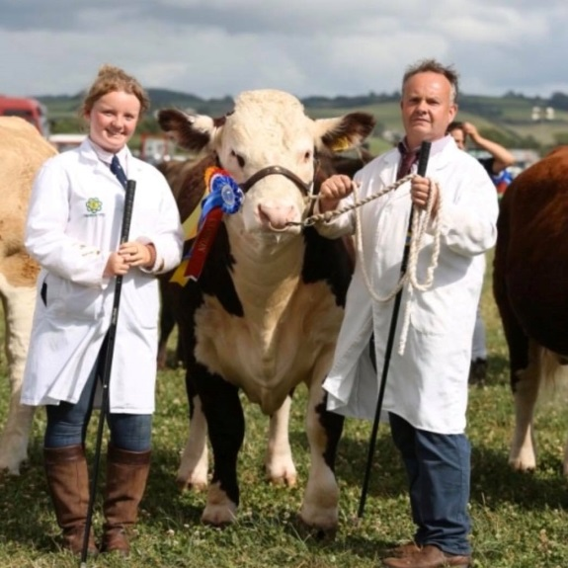
We are going to see this year as a little bit of a transition period for moving forward. Many thanks to Les Gould who has taken the chair, whilst we tackle the challenges ahead and prepare for a promising approach to the way forward for our association.
My aim this year as vice chairman with your input is to find out what we’re all looking for from the association, and to see what we can do to make this work for you the members. So do please let me know your thoughts and suggestions of what you would like to see, do and happen for us to have a strong association and a strong presence for our area within the breed.
Do please let me know and please make yourself known to me should I be allowed out in public!
Thank You Colin Layzell
HERD VISIT
Sunday 8th MAY 2022 : LUNCH AND FARM VISIT to LANSCOMBE HEREFORDS to be held at Higher Henley Farm, Buckland Newton, Dorchester, DT2 7BL by kind permission of Mr & Mrs Roger and Valerie Mitchell and family. # # # Overall Winners of the SWHA Herd competition 2021 # # #
Lunch is a Carvery at the The Halsey Arms, Pulham, Dorchester DT2 7DZ. 12:30 for 1pm. Please ring Angela Kerslake 07973 452403 or email southwestherefordassoc@gmail.com for further details or book your place so we have an idea of numbers for food. Please pay direct on the day. Carvery is £13.95 and desserts are £5.95.
Arrive at Higher Henley Farm at 2:30pm. Tour of the herd, clipping and preparing cattle for the show/sale ring demonstration. Tea/coffee afterwards. All welcome.

BREED STAND
The 2022 DEVON COUNTY SHOW will take place on Thursday 30th June, Friday 1st and Saturday 2nd July . We have a breed stand throughout the three days in the cattle lines. Please come along and join us for a chat and enjoy a drink.

HERD VISIT
Saturday 13th August 2022 : FARM VISIT to TWILIGHT HEREFORDS, West Bridge Farm, Milton Damerell, Newton St Petrock, Torridge, Devon. EX22 7LL by kind permission of Alex Gifford and family. (What3Words : carting.excellent.craftsmen )
Please arrive at the farm at 2pm for the herd visit. Stock judging competition led by Edward Mills. BBQ and social afterwards. Please let us know numbers attending so that we may cater for you.

HERD COMPETITION 2022
We are now accepting entries from SWHA members for this year's Herd Competition, to take place in July/August and will be judged by the 2021 winners in each category.
If you would like to enter, please reply stating how many breeding cows you have in your herd. (Registered and calved females)
As usual, there will be three sections:
Small herd : Under 15 breeding cows, Medium Herd 15 to 35 breeding cows, Large Herd Over 35 breeding cows or equally divided as the judge sees fit. Awards are for Best Stock Bull, Best Heifer Calf, and Best Bull Calf in each class.
Trophies and prizes will be awarded at the A.G.M. later in the year. Including ones to keep!
The entry fee for the Herd Competition is £20.00. Entries close 30th June
S.W.H.A. BACS DETAILS : Sort code 30-91-20 A/C No. 00611783. Please use your surname and/or your Hereford Society Membership Number as a reference.
CHEQUES payable to South Western Hereford Association. Post to SWHA Secretary. Angela Kerslake, Nicholashayne Farm, Sampford Arundel, Wellington, Somerset. TA21 9QY

MEMBERSHIP
Annual Subs are due 1st October

£25
A decision was made at the AGM on 28th November 2021 to increase the Sub from £10 to £25 as of 1st October 2022.
Members of the SWHA can take advantage of free advertising and promotion of your herd on the SWHA Website, Facebook and Instagram. We can set you up a Web Page of your own which can be continually updated and/or inclusion on the SWHA advert in the breed journal – upon request. This allows potential purchasers to find you and your information easily. Our new website ranks quite highly in most search engines. Social functions, herd walks & competitions and get togethers are held throughout the year.
Please contact Angela Kerslake with your information to: southwestherefordassoc@gmail.com or by post to: Nicholashayne Farm, Sampford Arundel, Wellington, Somerset. TA21 9QY.
Please make cheques payable to ‘South Western Hereford Association’
Or if you wish to pay by Standing Order : South Western Hereford Association,
Bank details are: Sort code: 30-91-20 Account Number: 00611783
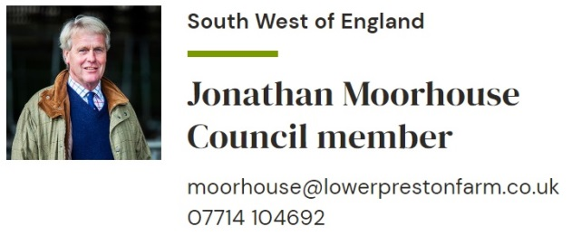

Facebook page : facebook.com/southwestherefordassociation
INSTAGRAM
@sw_hereford_association
SWHA Website: www.herefordssouthwest.com

