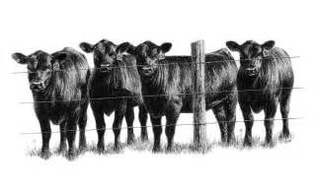
SEDGEMOOR
CALF SHOW
ENTRY FORM
Friday 3rd February 2023 at Sedgemoor Auction Centre

Name: | Telephone Number:  Insurance Policy Number:
Address: |  | Elite Health:

Class No | Animal Name | Eartag Number | Date of Birth | Pedigree
Sire:

Dam:

Sire:

Dam:

Sire:

Dam:

Sire:

Dam:

All entry forms to be returned to HALEY BRIDGEMAN, GREENSLADE TAYLOR HUNT, SEDGEMOOR AUCTION CENTRE, NORTH PETHERTON, BRIDGWATER, SOMERSET. TA6 6DF
All entries to be received by Monday 23rd January

